Database Name: anomaly

Table Name: register

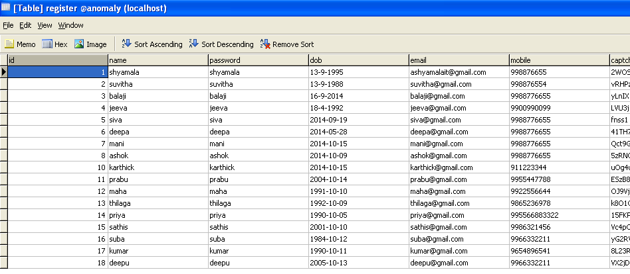

Table Name: following

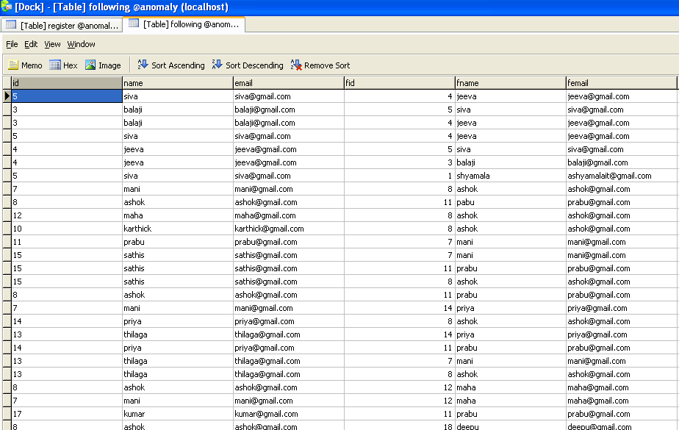

Table Name: message

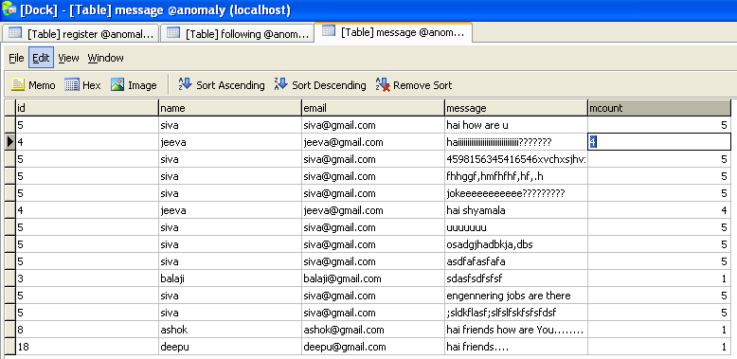

Table Name :photo

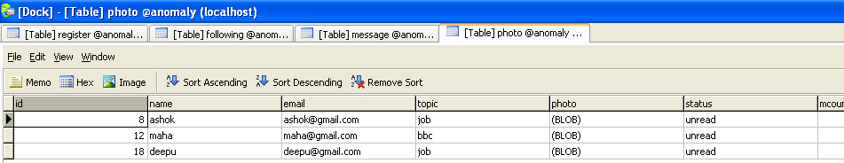

Table Name: remessage

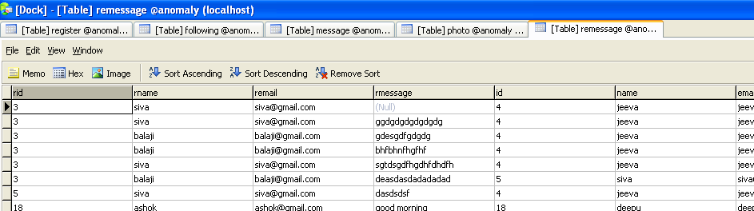

Table Name: rephoto

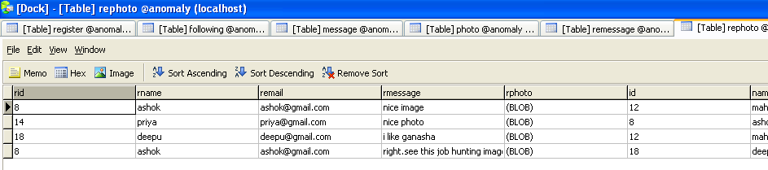

Table Name: retweet

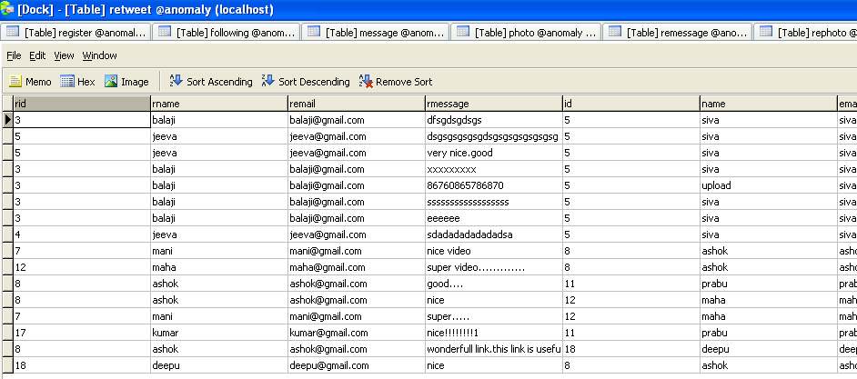

Table Name: revideo

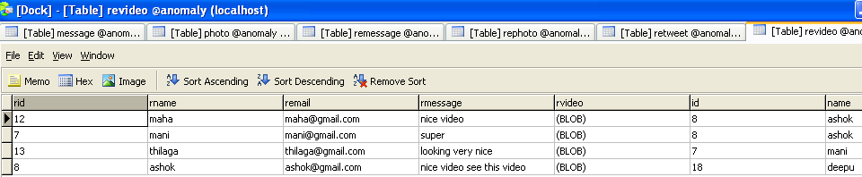

Table name: tweet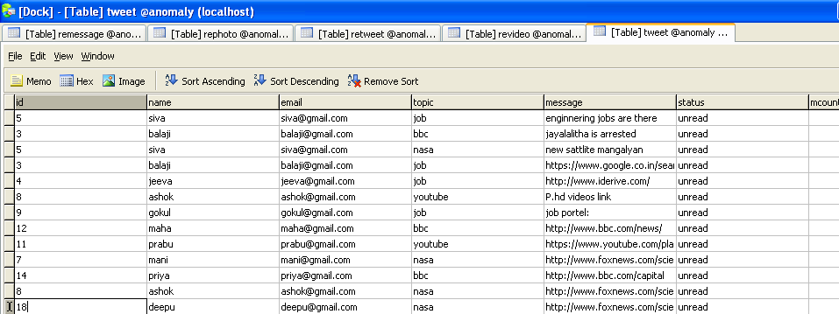

Table Name :video

